

[This Photo](https://www.ryansmithphotography.com/family-gallery/) by Unknown Author is licensed under [CC BY-NC-ND](https://creativecommons.org/licenses/by-nc-nd/3.0/)

**Materials:**

1. pictures of family and pets





[This Photo](https://crockerchronicle.blogspot.com/2011/09/are-big-families-more-fun.html) by Unknown Author is licensed under [CC BY-SA-NC](https://creativecommons.org/licenses/by-nc-sa/3.0/)

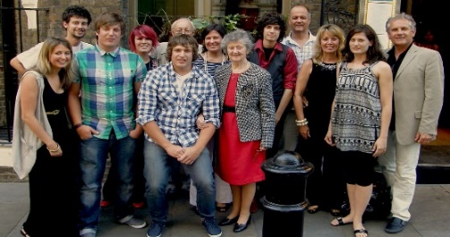

[This Photo](http://www.flickr.com/photos/jdlrobson/4848719723/) by Unknown Author is licensed under [CC BY](https://creativecommons.org/licenses/by/3.0/)



[This Photo](https://www.flickr.com/photos/gageskidmore/29347022846/) by Unknown Author is licensed under [CC BY-SA](https://creativecommons.org/licenses/by-sa/3.0/)

2.Pictures of famous people

2.Pictures2ppe

people



[This Photo](https://www.abruzzo24ore.tv/news/Brad-Pitt-festeggia-i-50-anni-Per-regalo-oltre-l-isola-ricevera-l-Oscar/131492.htm) by Unknown Author is licensed under [CC BY-NC-ND](https://creativecommons.org/licenses/by-nc-nd/3.0/)



[This Photo](https://en.wikipedia.org/wiki/Will_Smith) by Unknown Author is licensed under [CC BY-SA](https://creativecommons.org/licenses/by-sa/3.0/)



[This Photo](https://www.flickr.com/photos/11304375@N07/2923659934/) by Unknown Author is licensed under [CC BY](https://creativecommons.org/licenses/by/3.0/)

3.Colored dry-erase markers

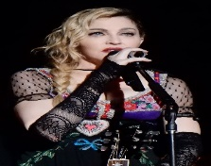

[This Photo](https://cs.wikipedia.org/wiki/Madonna) by Unknown Author is licensed under [CC BY-SA](https://creativecommons.org/licenses/by-sa/3.0/)



[This Photo](https://www.hit-channel.com/grammy-awards-2017-highlights/113933) by Unknown Author is licensed under [CC BY-NC-ND](https://creativecommons.org/licenses/by-nc-nd/3.0/)

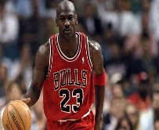

[This Photo](https://historia-biografia.com/michael-jordan/) by Unknown Author is licensed under [CC BY-SA-NC](https://creativecommons.org/licenses/by-nc-sa/3.0/)

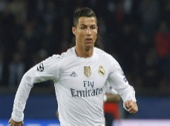

[This Photo](http://www.africametro.com/sports/cristiano-ronaldo-joining-juventus-in-e100million-deal-from-real-madrid) by Unknown Author is licensed under [CC BY-SA-NC](https://creativecommons.org/licenses/by-nc-sa/3.0/)

4.sticky tape



[This Photo](https://en.wikipedia.org/wiki/Masking_tape) by Unknown Author is licensed under [CC BY-SA](https://creativecommons.org/licenses/by-sa/3.0/)

**worksheets:**

List of Adjectives

**Look Personality**

tall kind

chubby mean

skinny creative

young hardworking

old funny

small serious

bold friendly

pretty quiet

attractive lazy

cute loud

handsome brave

strong shy

short noisy

ugly intelligent

fast popular

slim honest

Practice 1 worksheet

1. Match the columns

kind does not talk a lot

athletic works a lot, works hard

creative make others laugh

hardworking not willing to work

funny very loud; talks loudly and a lot

serious nice to other people

friendly does not smile a lot

quiet strong body, muscular

lazy original, productive

noisy warm, social, likes to talk

Practice 3 worksheet

1. Write the correct adjectives and make comparative forms in the sentences below:

**-big -young -smart**

**-pretty -noisy -friendly**

**-funny -attractive -loud**

1. My mom is __________, but my dad is ___________ because he tells better jokes.
2. My sister is so __________, but my brother is ________. He speaks three languages.
3. She has such a beautiful face. She is ___________ than her sister.
4. Some babies cry a lot. They are _____________ than other babies.
5. I am so _________, but my sister is ___________. She knows so many people.
6. Our dog barks all the time. He is so __________, but my neighbor’s dog is even _________ than him.
7. He has a three-story house. It’s so much _______ than ours.
8. My little sister is ________ than all of us in the family. She is only 9 years old.
9. My husband is such a good-looking guy. He is __________ than his best friend.

Homework sheet

1. Show comparison using an adjective with one syllable

_________________________________________________________. (old)

(adjective + er + than)

1. Show comparison using an adjective with one or more syllables that end in “y’.

(y🡪 ier + than)

_________________________________________________________. (skinny)

1. Shoe comparison using an adjective with more than one syllable that doesn’t end in “Y”.

_________________________________________________________. (intelligent)

(more/less + adjective +than)

Works Cited:

* The fundamentals of teaching English as a second language, International TEFL academy press, Sixth edition, 2019.
* <https://www.eslprintables.com/buscador/search.asp?nivel=any&age=18&tipo=lesson-plan&contents=comparatives+with+famous+people&username=&B2=Search>